**First and Second Order Phase Transitions in the 2-D Ising Model of Ferromagnetism**

##### **Dylan Hilligoss1**

1 Department of Physics and Astronomy, University of Delaware

**Abstract**

The following data and results were collected for the 2D Ising model using the Monte Carlo Metropolis algorithm. This system was structured to be a 128x128 lattice of spins placed in some external magnetic field, *B*. Under certain initial conditions and periodic boundary conditions, it is found that this system can undergo a first or second order phase transition. To better understand the nature of these phase transitions, the magnetization will be calculated over a changing magnetic field, and a changing temperature using the Monte Carlo algorithm. It is found that this system of lattices shows hysteresis for first order phase transitions. Another key result is the sharp spike in the system’s specific heat and magnetic susceptibility around the critical temperature during a second order phase transition.

PACS numbers: 2.70.Uu, 75.10.Hk

1. **Introduction**

The driving principle and motivation behind these series of calculations stem from the use of the Monte Carlo algorithm. The Monte Carlo algorithm (MC hereafter) is a procedure used for numerical analysis of large systems that rely on repeated random sampling in order to obtain the desired results. The principle behind this method is the use randomness to solve problems that may be deterministic, or well-defined, in nature.

The system in study here consists of a 128x128 square lattice of spin values defined by either -1 or +1. These values represent either a spin up or spin down configuration respectively. Individual and neighboring spins will then be used to calculate the energy of each spin.

* 1. **Normalization**

One of the first steps that must be done is to normalize the energy of each individual spin at every step throughout the system. By calculating the energy at every step, it can be determined whether a particular spin needs to be flipped or left alone. Equation 1 (1) shows the calculation of energy *H* for a particular state in the system:

$$H=-J\sum_{i,j}{σ_{i}σ_{j}-B\sum_{i}{σ_{i}} (1)}$$

Eq. (1) clearly has units of energy. To start solving for *H*, notice that *J* must also have units of energy. Dividing by *J*, equation 2 is obtained.

$$\frac{H}{J}=-\sum_{i,j}{σ_{i}σ_{j}-\frac{B}{J}\sum_{i}{σ_{i}} (2)}$$

Assuming *J=1*,

$$H=-\sum_{i,j}{σ_{i}σ_{j}-B\sum_{i}{σ_{i}} (3)}$$

Equation 3 is the normalized version of (1) which will be used throughout this program as a method for solving spin energies. Since (3) will only be used to calculate the energies of individual spins *σ*, the summations, and therefore the energy *H*, can be simplified. The first summation term is understood to be calculating the sum of the four neighboring spins to *σi*. This is then just multiplied by the second term, *Bσi*.

The resulting energy *H* then equals:

$$H=x-Bσ_{i} (4)$$

Where *x* lies in the range from -4 to +4.

Using this normalization for energy will be extremely useful going forward when calculating spins and energies using the MC method.

1. **Methodology**

To begin analyzing this system, it must be recognized that this program will simulate a MC sampling of random coordinates throughout the lattice. The energies of each spin will be calculated to determine if the spin should be flipped or not. The initial conditions such as the energy provide the necessary parameters in the calculation of whether a spin should be flipped or not. These initial conditions will determine the sign of each spin’s Δ*H*.

$$∆H=H_{f}-H_{i} (5)$$

Here, *Hf* is the energy of the spin if it is flipped while *Hi* is the energy of the current spin configuration. If Δ*H* is negative, this implies that it would take less energy for the lattice to change to this new configuration. Therefore, multiplying by

-1 will represent the spin’s directional reversal.

However, if Δ*H* turns out to be a positive number, then more energy is required to reconfigure the lattice. Now, instead of simply multiplying by -1, the probability that a spin will flip directions can be calculated by equation 6.

$$p=e^{-\frac{∆H}{k_{B}T}} (6)$$

Where *kB*=1and *T* are the normalized Boltzmann constant and temperature respectively.

From (6), one can see that as *T* increases, so also does the probability of the spin flipping orientation.

Using these facts and (6), the next important term to know is the magnetization of the system. The magnetization in equation 8 is found by summing all the individual spins and dividing it by the size of the lattice (in this case, it would be 1282=16,384).

This process will be calculated 1,000 times for each value of *B* to ensure maximum accuracy in the MC algorithm computation.

*2.1.* **Phase Transitions**

This lattice configuration is capable of undergoing a first or second order phase transition. In this problem, aspects of both of these transitions will be examined.

*2.1.1* 1st Order Phase Transitions

For this type of transition, the main goal is to find the relationship between the mean magnetization as a function of *B*. In this setup, the MC algorithm will calculate values for a positive sweep up from *B=-5* to *B=5* and a negative sweep down from *B=5* to *B=-5*. The temperature *T* will be set equal to 1.00 throughout this calculation as well. Another important thing to note is that the first 100 values will be discarded from the calculation in order to account for the system settling into a thermal equilibrium.

The first order phase transition is easily noticed in a magnetization vs. *B* plot because of its discontinuity which will be examined in the Results section of this paper. Another interesting piece of information will also become apparent as a result of this type of transition. This will, again, be emphasized in the Results section found below.

After completing this calculation, the same procedure will be implemented again; only now, *T=4* instead of 1. Such a seemingly insignificant change will, in fact, produce completely different results. See (6) to note how at higher temperatures, the spin is more likely to flip directions.

One other important piece of information is the calculation of the autocorrelation function. By doing this calculation, one can develop an educated estimate of the number of independent samples in the MC simulation. The autocorrelation function is defined in equation 8.

$$C_{m}\left(τ\right)=\frac{〈m\left(t+τ\right)m\left(t\right)〉-{〈m〉}^{2}}{〈m^{2}〉-{〈m〉}^{2}} (8)$$

Where τ is a autocorrelation scaling factor. This calculation was done for *B=0,+2,* and *-2.*

*2.1.2* 2nd Order Phase Transitions

For the second order phase transition, the primary focus in this problem will be to investigate three different temperatures in three different physical regimes of the system. *T<TC*, *T=TC*, and *T>TC*. Again, the MC algorithm will be used to calculate magnetization and energy per spin. Note that throughout this entire part, *B=0* and will not change.

Two other important thermodynamic quantities will also be examined, the specific heat and magnetic susceptibility. Specific heat is the heat required to raise the temperature of the unit mass of a given substance by a given amount (usually 1 degree Celsius). For the lattice being examined in this problem, the specific heat is defined as:

$$C_{V}=\frac{1}{N_{S}}\frac{1}{k_{B}T^{2}}\left(〈E^{2}〉-{〈E〉}^{2}\right) (9)$$

Where *E* is the total energy and *NS* is the number of steps. The magnetic susceptibility is defined as a measure of how much material will become magnetized in a given applied magnetic field. For the lattice configuration posed in this problem, the magnetic susceptibility is defined in equation 10.

$$=\frac{1}{N_{S}}\frac{1}{k_{B}T}\left(〈M^{2}〉-{〈M〉}^{2}\right) (10)$$

Here, *M* is the total magnetization of the state.

The specific heat and magnetic susceptibility will be examined for increasing values of temperature.

Finally, a production of the final configuration of the MC simulation will be given as a lattice of black and white pixels to emphasize how the number of spin flips changes as temperature is increased.

1. **results**

Now that a valid method for solving the system has been given, it is time to review interesting effects of first and second order phase transitions. As stated above, the MC simulation will be run over a 128x128 square lattice with each step being calculated 1,000 times.

*3.1* **1st Order Phase Transitions**

To begin, consider a system with a constant temperature. First, *T* will be set to 1.0. Then, *T* will be set to 4.0 to study the differences between the relationship between mean magnetization and magnetic field.

*3.1.1* Magnetization and Magnetic Field

One effective way to spot a first order phase transition is through the examination of the mean magnetization ($\overline{m}$) as a function of magnetic field (*B*). Figure 1 shows the mean magnetization for a broad range of magnetic field values at *T=1*. Specifically, *B* undergoes a positive sweep from -5 to +5, then reverses to form a negative sweep from +5 back to -5.

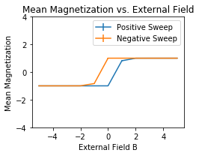

Figure : This plot shows the mean magnetization as a function of the external magnetic field at T=1.00. Initially, the calculation is done from B=-5 to B=5. Then it is reversed and reconducted from B=5 back to B=-5. Notice the discontinuity and hysteresis present.

As seen in Figure 1, both the positive and negative sweep make a jump from negative to positive and vice a versa respectively. The region between the two sweeps is called hysteresis. Hysteresis is the phenomena in which a system’s future is influenced by its history. Even though the positive and negative sweep follow the same form, since they are inverses of each other, the jump occurs at a different value of *B*. This signals that the phase transition will occur at differing *B* values depending on the direction of the sweep.

However, as shown in Figure 2, when *T=4*, the positive and negative sweeps follow much closer together. The hysteresis is all but eliminated, implying that the phase transition for higher temperatures occurs at roughly the same magnetic field value.

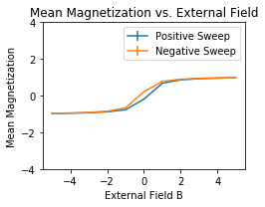

Figure : This plot shows the mean magnetization as a function of the external magnetic field at T=4.00. Initially, the calculation is done from B=-5 to B=5. Then it is reversed and reconducted from B=5 back to B=-5. Now notice the lack of discontinuity and hysteresis present.

Since these phase transitions occur around B=0, there is plenty of excess thermal energy at higher temperatures for the spins to realign themselves to oppose B. However, this will cease to occur as the gap between T and B decreases.

*3.1.2* Autocorrelation Function

Another important thing to note are the fitted autocorrelation functions for specific values of *B*. The calculation of the autocorrelation function allows one to estimate the number of independent samples in the MC simulation. Figures 3-6 show the fitted autocorrelation functions during the positive and negative sweeps for *T=1* and *T=4*.

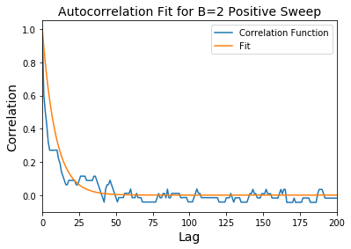

Figure : This figure shows the autocorrelation function fitted to an exponential when T=1 and B=2 during the positive sweep.

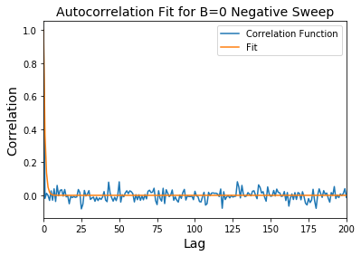

Figure : This figure shows the autocorrelation function fitted to an exponential when T=1 and B=0 during the negative sweep.

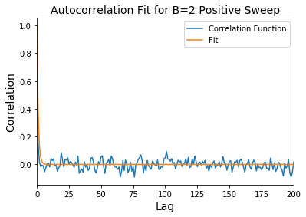

Figure : This figure shows the autocorrelation function fitted to an exponential when T=4 and B=2 during the positive sweep.

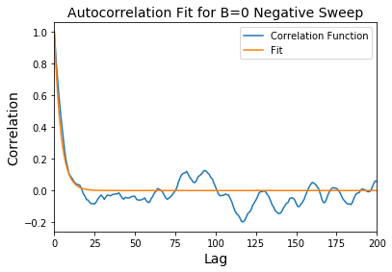

Figure : This figure shows the autocorrelation function fitted to an exponential when T=4 and B=0 during the negative sweep.

These calculations were made using (8). Figures 3.6 seem to fit well to an exponential decay function. The fitting values of τ were 9 and 1 for Figures 3 and 4. For Figures 5 and 6, τ was set to 1 and 4 respectively.

*3.2* **2nd Order Phase Transition**

Another important question to answer is how many MC steps it takes *T* to thermalize. Thermalization occurs when the spins have enough energy that they can be oriented in any direction regardless of the value of the magnetic field. To examine if and when thermalization occurs, *B* will be set to 0 for the duration of this section. The system will be tested for the following 4 cases: *T=1.00*, *T=2.269* (critical temperature), *T=3.00*, and *T=5.00*. Specifically, the magnetization and energy per spin will be evaluated. Next, the values of specific heat and magnetic susceptibility found in (9) and (10) will be examined to note their relationship to an increasing temperature. Finally, MC simulations of the final lattice configurations will be presented.

*3.2.1 Magnetization and Energy*

First, the magnetization and energy per spin will be examined. Figures 7-10 show the magnetization per spin for increasing values of *T*. Notice how the magnetization becomes much more defined for temperatures above the critical temperature. The graphs seem to settle into a “pseudo constant” line with smaller amounts of noise for higher temperatures.

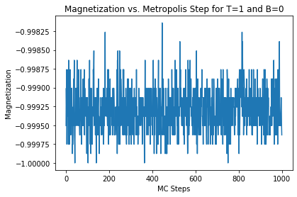

Figure : This plot shows the magnetization per spin for T=1. Notice how for a low T value, the magnetization fluctuates wildly for every MC step value.

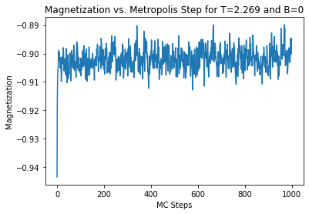

Figure 8: This plot shows the magnetization per spin at the critical temperature of T=2.269. Here, one can see a noticeable trend in data with a smaller amount of variation.

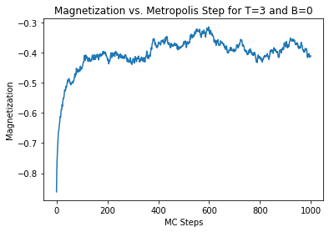

Figure 9: This figure shows the magnetization per spin when T=3.00. Notice now that the variation in data is quite small and it follows a well-defined path.

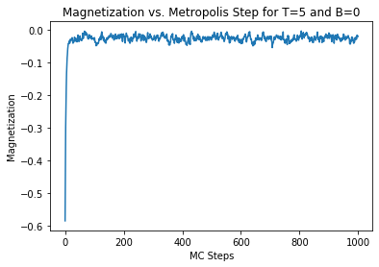

Figure 10: This plot shows the magnetization per spin when T=5.00. Now there is very little variation in the magnetizations per spin. The data follows an extremely well-defined path.

Figures 11-14 now will show the corresponding energies per spin as *T* is increased. Similarly to the magnetization per spin shown in Figures 7-10, the energy per spin graphs will look very similar. As temperature *T* is increased, the amount of variation in the energy data is decreased.

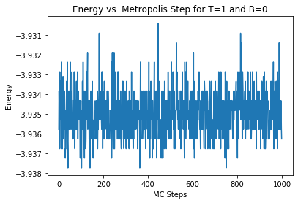

Figure 11: This plot shows the energy per spin for T=1. Notice how for a low T value, the energy fluctuates wildly for every MC step value.

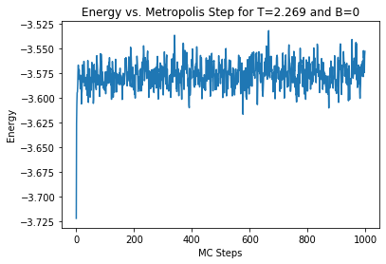

Figure 12: This plot shows the energy per spin at the critical temperature of T=2.269. Here, one can see a noticeable trend in data with a smaller amount of variation.

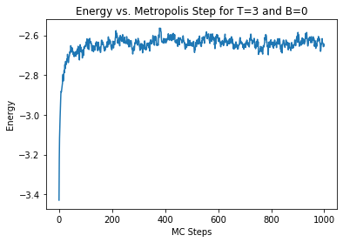

Figure 13: This figure shows the energy per spin when T=3.00. Notice now that the variation in data is quite small and it follows a well-defined path.

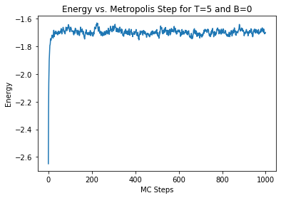

Figure 14: This plot shows the energy per spin when T=5.00. Now there is very little variation in the energies per spin. The data follows an extremely well-defined path.

Examining the magnetizations and energies per spin allows one to gather a more in-depth analysis of how the simulation is working and what happens to the lattice at higher temperatures.

*3.2.2 Specific Heat*

Next, the specific heat of the system will be examined. As previously stated, specific heat is the amount of heat required to raise the temperature of some unit of mass by 1 degree. Its quantitative value is represented by equation 9 (9). Figure 15 plots the specific heat as a function of temperature. Around the critical temperature of 2.269, the specific heat spikes up. This spike indicates the presence of a phase transition. It is at this critical temperature where the phase transition occurs. Subsequently, the specific heat will reflect this fact.

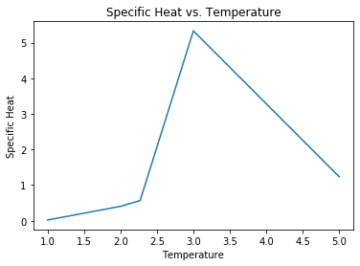

Figure 15: This figure represents the specific heat as a function of temperature. Notice the spike in specific heat at values around the critical temperature. This suggests the existence of a phase transition at this point.

*3.2.3 Magnetic Susceptibility*

The magnetic susceptibility of the system is also an interesting quantity worth measuring. Again, magnetic susceptibility is the measure of how much material will become magnetized in an applied magnetic field. Equation 10 (10) reflects the quantitative value of magnetic susceptibility as a function of temperature since *B* has been set to 0. Figure 16 shows the nature of the magnetic susceptibility as a function of increasing temperature.

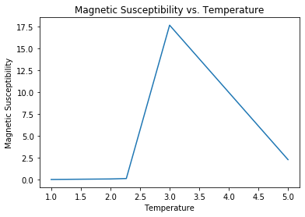

Figure 16: This plot shows the magnetic susceptibility as a function of temperature. Notice the spike around the critical temperature. This also provides evidence for a phase transition occurring at this point.

Similarly to the specific heat plot in Figure 15, Figure 16 also shows a spike in the magnetic susceptibility at values surrounding the critical temperature. This is further evidence of the presence of a phase transition. Material is more likely to become magnetized during a phase transition. The spike in Figure 16 shows this.

*3.2.4 2nd Order Final Configurations*

Finally, the MC algorithm was used to produce final lattice spin configurations for different values of temperature *T*. Figures 17-20 reflect the amount of flipped spins for increasing *T*. Note that the black pixels in the image represent spins that **have not** been flipped while white pixels represent spins that **have** been flipped.

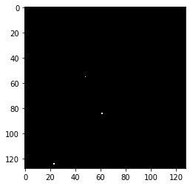

Figure 17: This plot shows the final lattice spin configuration when T=1.00. Notice how there are virtually no spin flips present in this configuration.

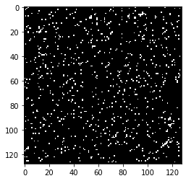

Figure 1: This plot shows the final lattice spin configuration when T=2.269, or the critical temperature. Now, there is a definite presence of flipped spins.

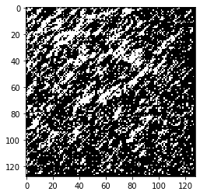

Figure 19: This plot shows the final lattice spin configuration when T=3.00. Here, the number of flipped spins continues to increase due to the increase in temperature.

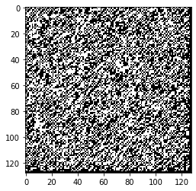

Figure 20: This plot shows the final lattice spin configuration when T=5.00. At such high temperatures, many more spins are likely to be flipped, as shown here.

As expected, as *T* increases, more and more spins are being flipped. This is because at higher temperatures, there is more available energy which the spins can draw upon to execute a flip.

1. **Conclusion**

In conclusion, both temperature *T* and magnetic field *B* have significant influences on the orientation of the spins found in this lattice. *T* and *B* also influence the type of phase transition that will occur. The presence of hysteresis in the mean magnetization vs. *B* plots suggests the existence of a first order phase transition. For lower temperatures, this transition will occur for differing values of magnetic field. Also, the existence of a second order phase transition can be found by looking at plots of the specific heat, magnetic susceptibility, and lattice spin configuration for increasing values of temperature. As temperature increases, spins are more likely to be flipped. Also, the magnetization will approach zero, which is called thermalization.

Ascertaining information about this lattice’s first and second order phase transition can yield much relevant and important information when studying complex physical systems like the paramagnetic and ferromagnet.